YALE RESUME TEMPLATE
By Resume Genius
City, State | (555) 555-5555 | yourname@email.com | linkedin.com/in/yourprofile

Education
Yale University New Haven, CT
B.A./B.S. in [Major] 20XX
- Expected Graduation: Month 20XX
- Relevant Coursework: Course 1, Course 2, Course 3, Course 4
- Awards: Dean's List, Honor Society, Academic Prize

Work Experience
Company Name City, State
Job Title Month 20XX – Month 20XX
- Achievement or responsibility with specific metrics and outcomes
- Achievement or responsibility demonstrating leadership or initiative
- Achievement or responsibility showing impact on organization

Company Name City, State
Job Title Month 20XX – Month 20XX
- Achievement or responsibility with quantifiable results
- Achievement or responsibility showing technical or analytical skills
- Achievement or responsibility demonstrating collaboration

Leadership Experience
Organization Name Yale University
Position Title Month 20XX – Month 20XX
- Leadership accomplishment showing team management or organizational impact
- Initiative you led or program you developed
- Result or outcome demonstrating leadership effectiveness

Organization Name Yale University
Position Title Month 20XX – Month 20XX
- Responsibility demonstrating initiative or problem-solving
- Achievement showing impact on community or organization
- Outcome demonstrating leadership or organizational skills

Skills and Interests
- Technical Skills: (optional)
- Language Skills: (optional)
- Interests: (optional)

Dear Job Seeker,
Ready to land your next job offer?
In addition to this Word template, we provide a whole host of expert resume and cover letter writing resources and tools that'll help you boost your job search and increase your chances of securing work.
Resume Builder →  How to Write a Resume → | Cover Letter Generator →  How to Write a Cover Letter →
Are you in a rush?
Speed up the application process by using a pre-formatted template:
Resume Templates →  Cover Letter Templates → | CV Templates →
Lastly, explore our job-specific resume and cover letter examples to ensure your finished application gives you the best chance of getting more interviews.
Resume Samples by Industry & Experience Level →
Cover Letter Examples by Industry & Experience Level →
Good luck on the job hunt.
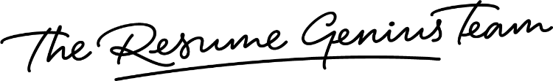
Best regards,

